1.Create image for backend instance

-select backend instance

-actions create images

2.go to target group

- HTTP 8000 (for backend)

-select your Vpc

-next

-create target group

3. go to load balancer

- create load balancer

- application load balancer

-give name to load balancer

- select internal facing(its backend and backend doesnt have internet)

-select vpc and in mapping your two private subnets

-security group= create security group

= give securtygroupname

= select vpc

=add inbound rules

=SSH …custom TCP 8000….All traffic

=give tag

= Create security group

=copy security group id

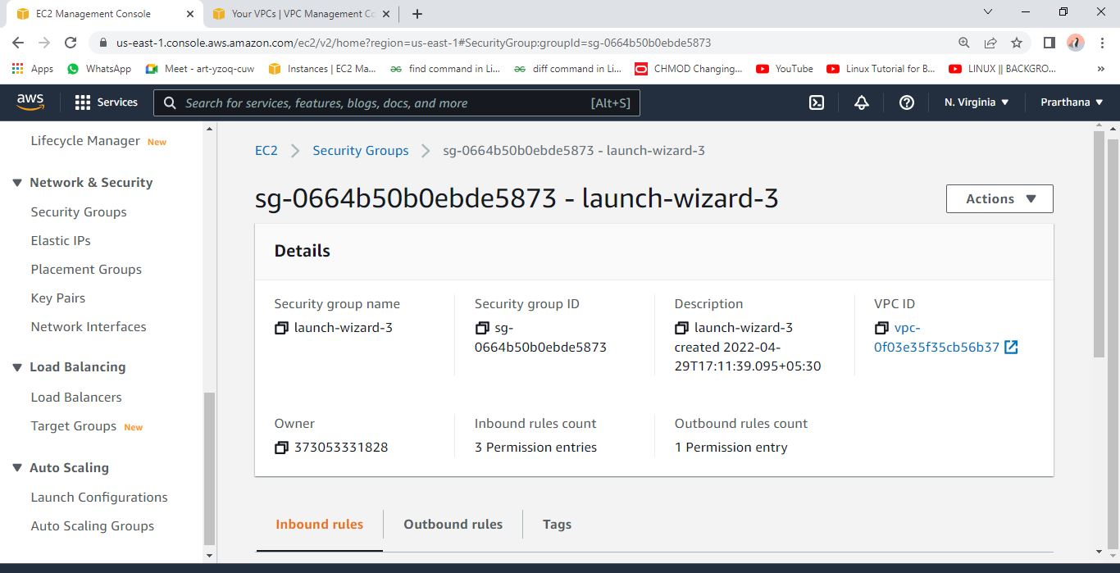

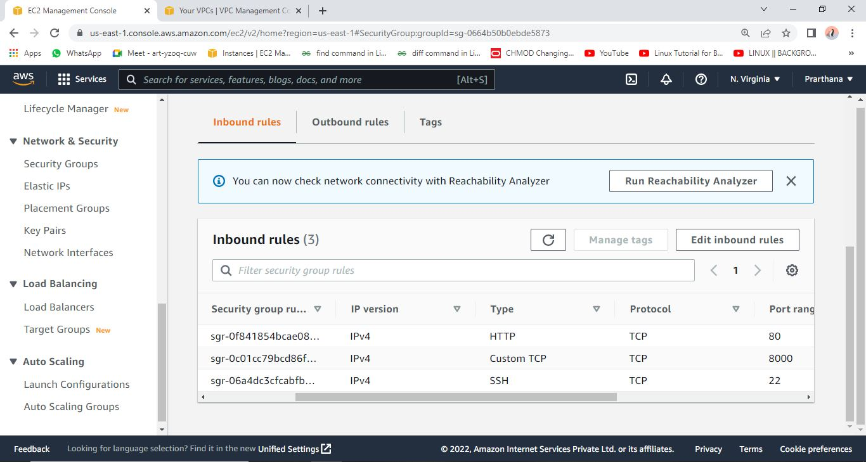

-paste on load balancer security group

-listener HTTP 8000 and select created target group

-click on create load balancer

1. Launch configuration

-create launch configuration

-give name and select backend ami

- select t2 micro instance type

-select security group private

-select existing key pair

-laucnch configurtion

1. Go to autoscaling

-create snd give name

-switch to launchconfiguration

-select created one launch configuration

-next

- select your vpc

-select both private subnet

-select maximum security group 2

-select target tracking scaling policies

-next

-add tag

-next

-create scaling group

6.go check target group healthy or not

7.stop backend server

---------------------------------------------Goto frontend--------------------------------------------------

1.open sudo nano /etc/nginx/sites-available/fundoo

2.go to load balcnacer copy ds name and paste in on the place of ip address

3.restart nginx and check status

sudo systemctl restart nginx

sudo systemctl status nginx

1.Create image for backend instance

-select backend instance

-actions create images

2.go to target group

- HTTP 80

-select your Vpc

-next

-create target group

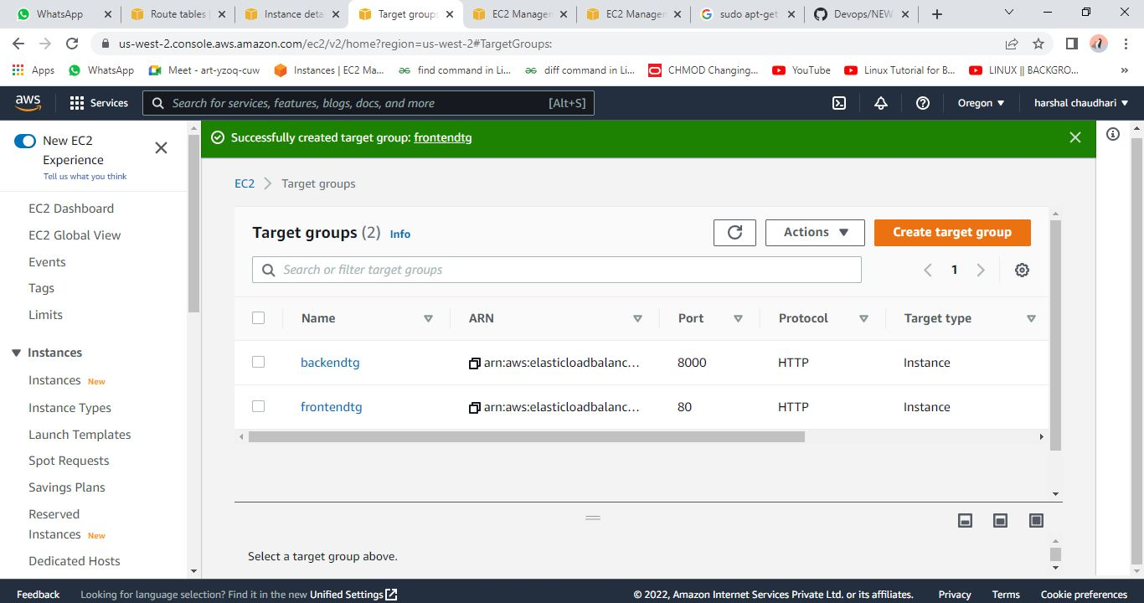

3. go to load balancer

- create load balancer

- application load balancer

-give name to load balancer

- select internet facing

-select vpc and in mapping your public subnet

-security group= create security group

= give securtygroupname

= select vpc

While selecting subnets create one more public subnet and do subnetassociation in public

=add inbound rules

=SSH …http 80

=give tag

= Create security group

=copy security group id

-paste on load balancer security group

-listener HTTP 8000 and select created target group

-click on create load balancer

1. Launch configuration

-create launch configuration

-give name and select frontend ami

- select t2 micro instance type

-select security group private

-select existing key pair

1. Go to autoscaling

-create snd give name

-switch to launchconfiguration

-select created one launch configuration

-next

- select your vpc

-select both public subnet

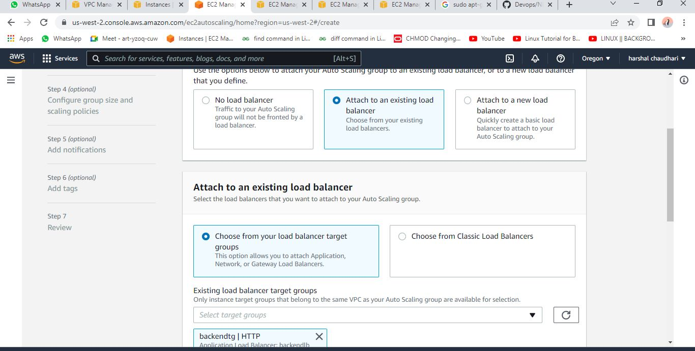

-select maximum security group 2

-select target tracking scaling policies

-next

-add tag

-next

-create scaling group

6.go check target group healthy or not

7.stop frontend one

Use stress command in putty to check the load

**tecmint@tecmint ~ $** **uptime**

**tecmint@tecmint ~ $** **sudo stress --cpu 8 -v --timeout 30s**

**tecmint@tecmint ~ $** **uptime**